Steps to Create AWS Billing Alerts on your Account

Step # 1 – Login in your account with root privileges

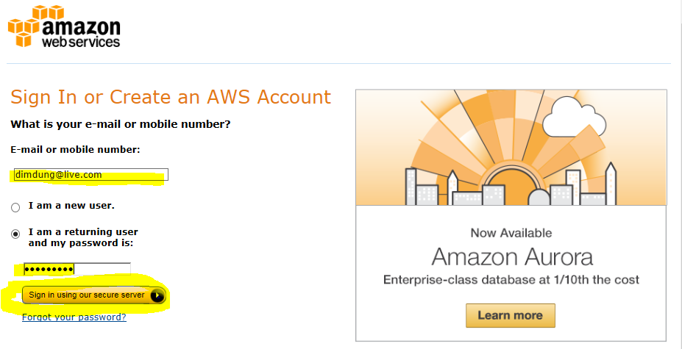

Step # 2 – Click on user **Samal Dimdung** upper right corner and select **Billing & Cost Managemnt**

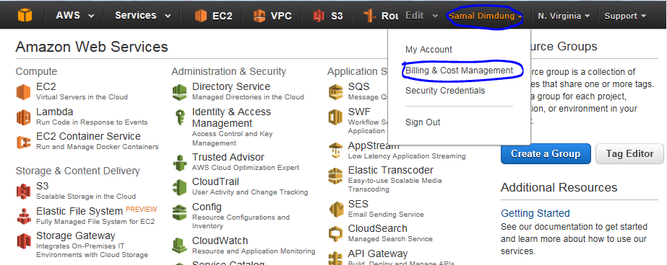

Step # 3 – Select **Preference**, checked the Receive **Billing Alerts** and click on “**Save Preference**”

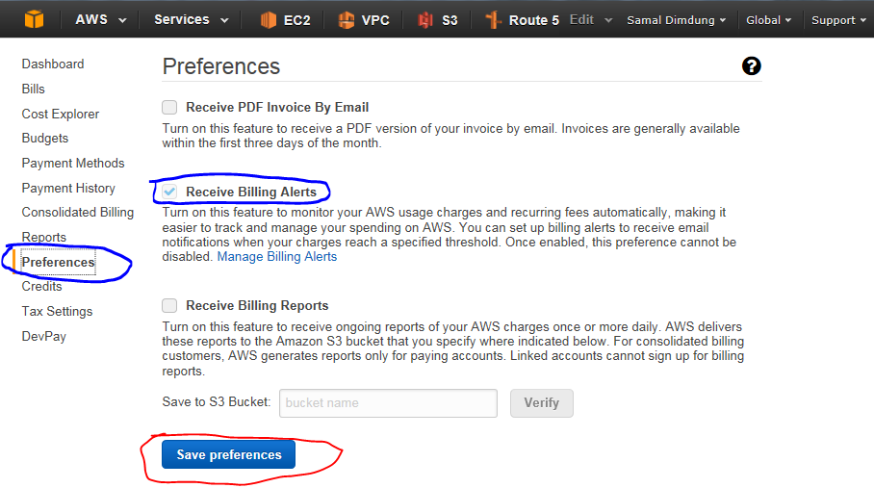

Step # 4 – Once done, Go to the **Main Console**, select the **CloudWatch**

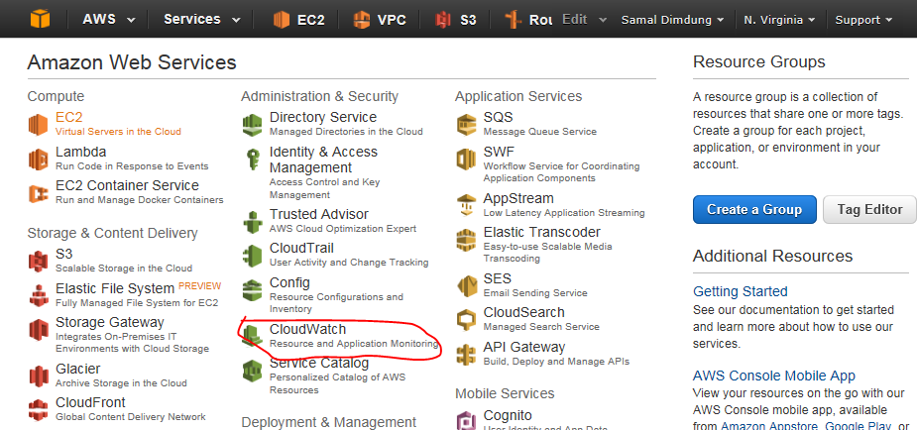

Step # 5 – On the Dashboard

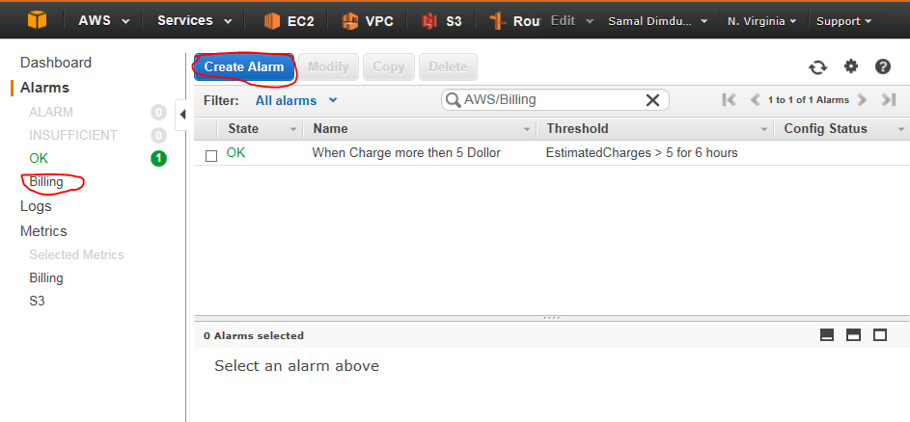

Step # 6 –

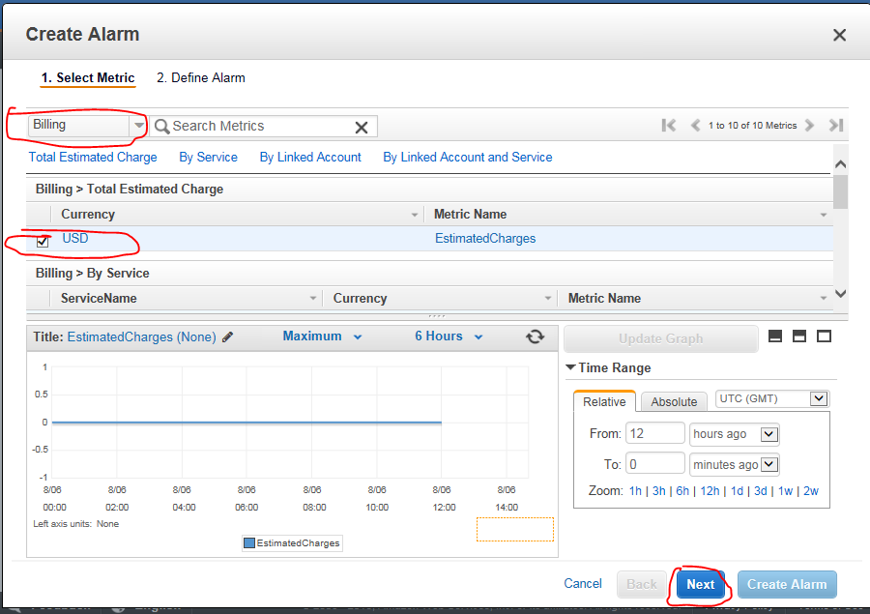

Step # 7 –

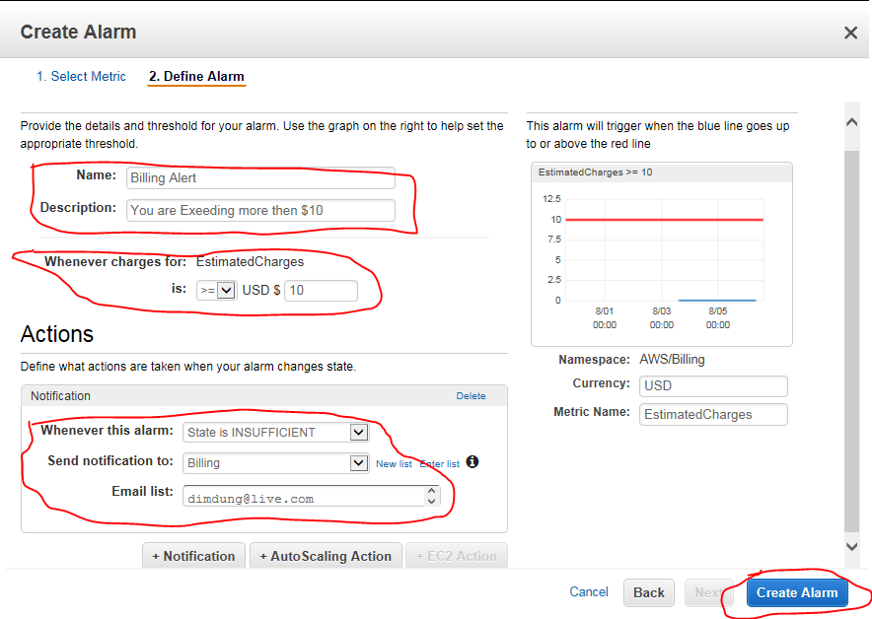

Step # 8 -

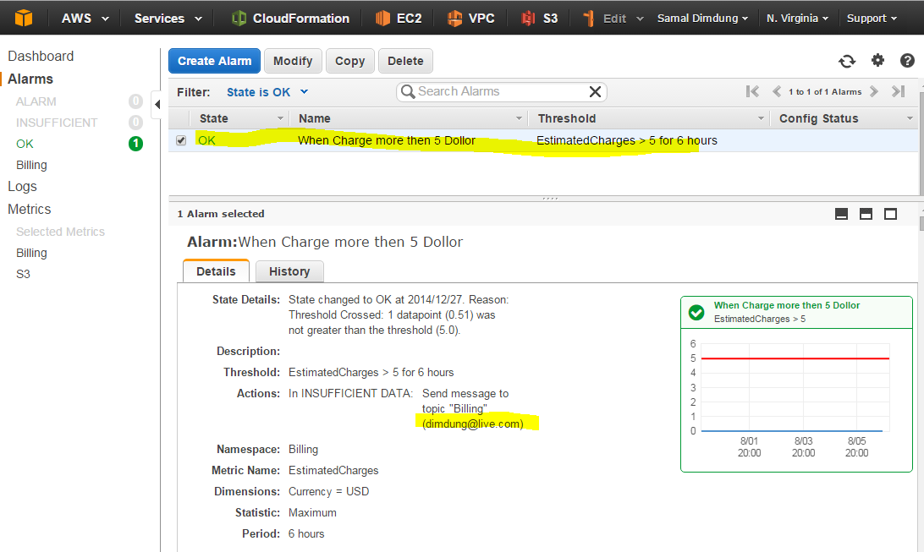

Step # 9 – You will get some message here like this …

